
Weave your family story, one thread at a time.

Final Report
CS147 Fall 2023
Jack Clark, Shuvi Jha, Jasmine Narine, Steven Pu
December 10, 2023

Table of Contents
Value Proposition & Team
Problem/Solution Overview
Needfinding
POVs & Experience Prototypes
Design Evolution
Final Prototype Implementation
Reflection & Next Steps

Our Design Process

Value Proposition & Team
Value Proposition
Weave your family story one thread at a time.

Team Members & Roles
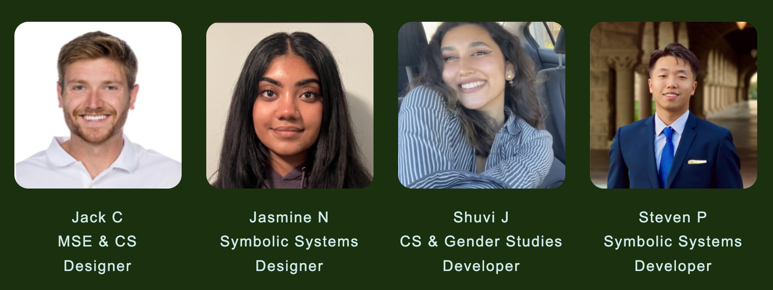

Problem/Solution Overview
It can be difficult for people to learn, share, discuss, and preserve family stories in a way that feels engaging and rewarding, especially across generations.

Kin is our solution to this problem space. It is a dedicated platform that facilitates intergenerational interaction and memory preservation through the use of daily prompts and collaborative features. By offering an array of engaging questions, Kin encourages users of all ages to contribute and explore family memories, fostering a shared space for storytelling.

Targeting families, with a special focus on young people and the elderly, Kin bridges the gap, making the process of storytelling more accessible, interactive, and enjoyable for everyone involved.

Needfinding Methodology
We started with an initial round of needfinding to uncover unmet needs within the following domain of preserving memories: people with current and past relationships with their aging family members.

It was important for us to interview a wide range of stakeholders. Our selection criteria included the following. We looked for diversity in:

- The age of our participants – in line with our problem domain examining generational relationships and aging.

- Levels of closeness with elderly family members – we wanted to hear from people who are both incredibly close and distant with their older family members as well as those who have a “normal” relationship with their elder family members.

- Views on storytelling, sharing, culture, and family stories.

- Personal identifiers such as race, gender, sexuality & socioeconomic status.

Collectively, we interviewed 5 people. We sourced 2 participants by asking passerby if they were interested in speaking with us at Town and Country, 2 participants from our extended network of friends and acquaintances, and 1 participant through Reddit (r/MountainView). Our youngest participant is 20 years old, and our oldest participant is 77 years old. Our participants come from differing backgrounds and cultures.

Synthesis
Following our interviews, we constructed individual empathy maps (Figures 1, 2, & 3) that allowed us to step into our interviewees’ shoes and better understand their actions, thoughts, and emotions regarding family stories & relationships as well as their experiences with storytelling. In reviewing interview notes and empathy maps, we discovered the following key learnings.

- While there's a strong desire to connect with and learn from older loved ones, the conversational style or the way information is conveyed by the elderly can sometimes be challenging for younger listeners to fully engage with or retain. This expresses a need for bridging the gap in communication styles and preferences between generations.

- The practice of recording family advice on a personal device by individuals in their middle age reflects a broader trend: the enduring value of familial wisdom across different life stages. This behavior points to a universal need for preserving and accessing family advice that remains relevant and impactful throughout one's life, not just in youth or old age.

- People possess meaningful family stories they wish to share, but they hesitate due to concerns about respecting the privacy and intimacy of their family relationships, which points to the importance of striking a balance between sharing and privacy.

- The diverse preferences and practices of storytellers in how they share their narratives highlight a key insight: individuals have varying needs for autonomy, privacy, and choice of communication mediums.

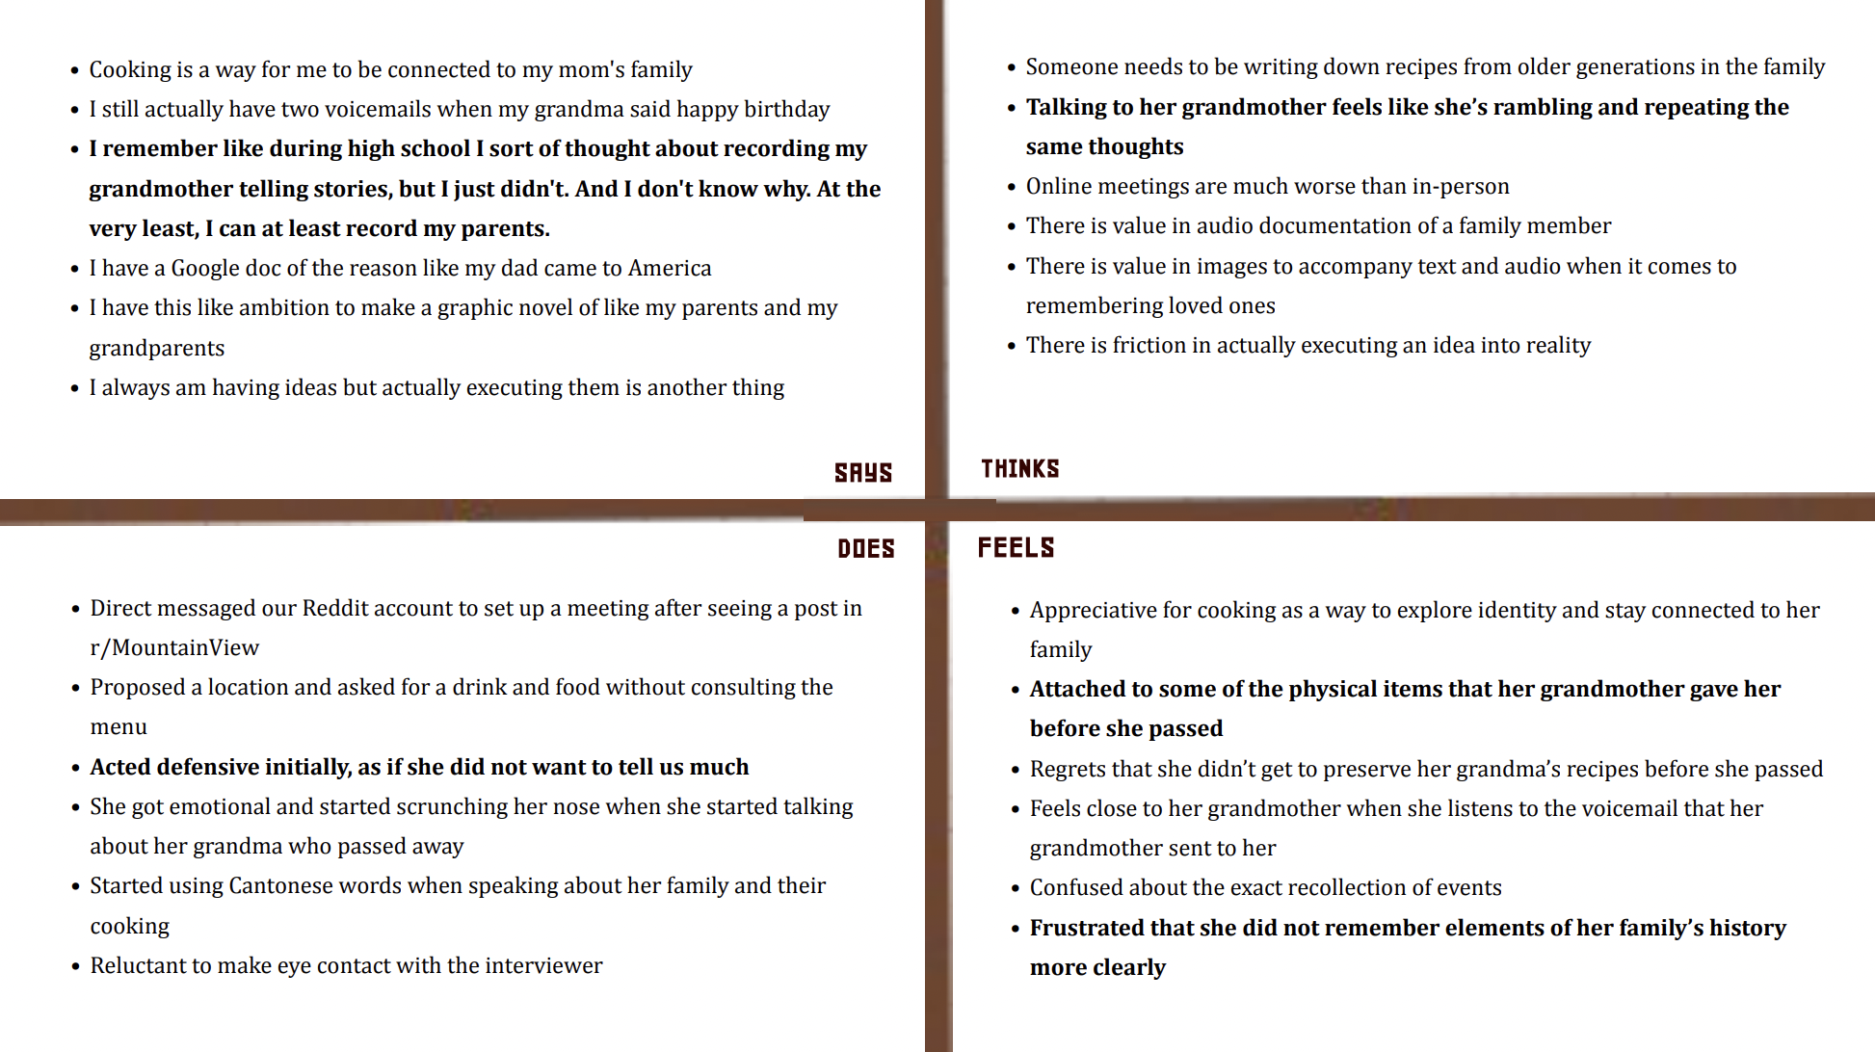
Figure 1. Empathy map for Catherine, a Cantonese woman in her mid-20s whose grandma passed away.

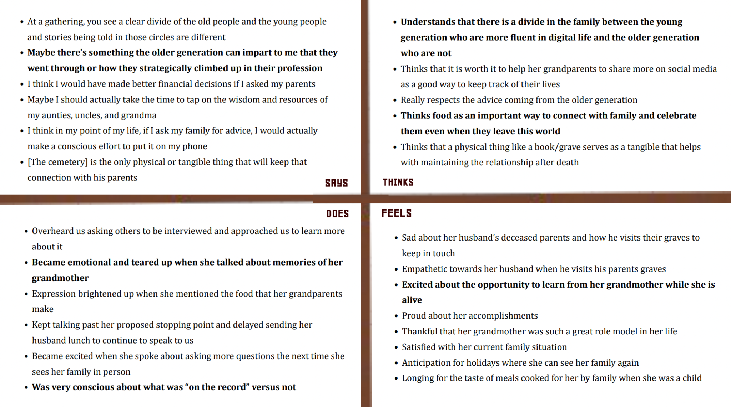
Figure 2. Empathy map for Clare, a Filipina woman in her late 30s whose grandmother is 96 years old

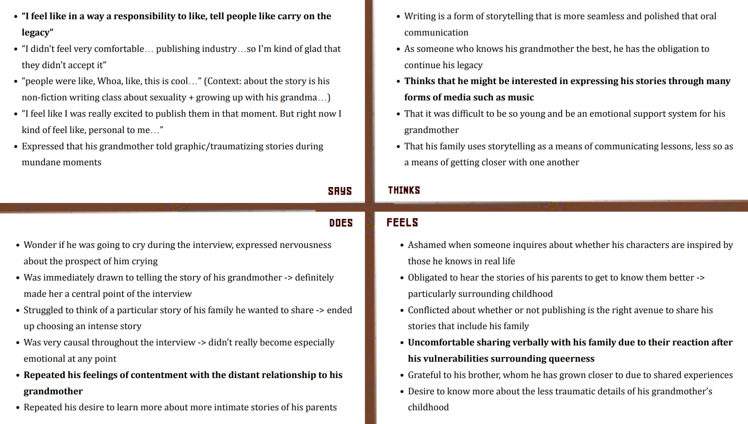
Figure 3. Empathy map for Sahir, a 20-year-old queer Kashmiri person and our extreme user who took on the role of a confidante in his relationship with his now 70-year-old grandmother during childhood.

POVs & Experience Prototypes
After identifying these preliminary needs, we began the process of developing user “Point of Views” and experience prototypes. We developed the following POVs for our three interviews, and came up with How Might We questions to guide our solution brainstorming:

POV #1 Krishna
WE MET A family. The son, Krishna, is in his mid-20’s working in tech in NYC, away from his family in LA. He loves cooking and family time. Last time the family was all together in-person was a year ago.

WE WERE SURPRISED TO NOTICE Krishna brightened up and took the initiative to take his phone out to record his mom as she shared a story she hadn’t shared before in the middle of the interview.

WE WONDER IF THIS MEANS that Krishna is interested in learning more about his family’s untold stories but does not have the mediums/chances of doing so when he is with his family.

IT WOULD BE GAME CHANGING to uncover untold family stories more easily and without pressure.

How Might We’s:
- Create more space for the family to share meaningful personal stories/journeys that they have not shared before?
- Create more opportunities to discover more untold stories through mundane conversations?
- Decrease the amount of casual and routine conversations with the family and increase the meaningful conversations when families are together?
- Help young people learn of the past that otherwise only exists in the minds of their older loved ones?
- Allow loved ones to maximize time spent together through engaging and spending limited time on their devices?
- Unobtrusively capture and cherish memories during valuable face-to-face conversations within families?

POV #2 Catherine
WE MET Catherine, a mid-20s Cantonese-American non-profit founder living in Mountain View.

WE WERE SURPRISED TO NOTICE she values time spent with her grandmother so highly that she moved from SoCal to the Bay Area to be physically closer to her, but that Catherine struggles to concentrate and listen to her grandmother “ramble” whenever they spoke before she passed.

WE WONDER IF THIS MEANS there is a two-sided problem of young people having difficulty concentrating in conversation and older people struggling to be concise and share their thoughts.

IT WOULD BE GAME CHANGING to find a way to bridge the communication gap between the younger and older generations.

How Might We’s:
- Assist old people in effectively communicating their wisdom and stories without losing train of thought?
- Assist young people in producing thoughtful questions to ask their loved ones?
- Provide peace of mind to younger people struggling with guilt surrounding the amount of interaction they have with elderly loved ones?
- Make it easier for young people to concentrate when communicating with an older relative?
- Create an engaging experience for both producing and consuming storytelling that transcends generational boundaries?

POV #3 Michele
WE MET Michele, a 77-year-old childless divorcee with a penchant for storytelling, a Stanford degree, and a passion for love.

WE WERE SURPRISED TO NOTICE that despite having a podcast during which she details her most intimate experiences with love, she is not concerned with privacy, but rather the ability to control her own narrative.

WE WONDER IF THIS MEANS that older generations have a desire to chronicle their lives, but want to do so in a way that honors their autonomy.

IT WOULD BE GAME CHANGING to ensure that the older generation has full control over how their stories are told, where these stories are distributed, and which audiences have access to them.

How Might We’s:
- Promote the stories of older gens to attract the audiences they’d like?
- Preserve the autonomy of older generations interested in storytelling?
- Increase awareness of the mediums available to older people?
- Provide older generations with inspiration to promote their storytelling?
- Facilitate the utilization of various, preferred storytelling formats?

Top 3 Solutions
Based on these POVs and HMW’s, we brainstormed a diverse array of solutions. Here, we highlight our top 3 solutions, rooted in the HMW’s be brainstormed above.
- HMW: Create an engaging experience for both producing and consuming storytelling that transcends generational boundaries?
  - SOLUTION: Conversation Helper – a tool that records a conversation and suggests questions and statements to help a younger audience foster engaging and heart-to-heart dialogues.
- HMW: Unobtrusively capture and cherish memories during valuable face-to-face conversations within families?
  - SOLUTION: Memory Game – a gamified way to prompt participants to share their stories. For example, a prompt could be: share a story that is most likely to make your grandma laugh. Players would then share family stories responding to the prompt.
- HMW: Facilitate the utilization of various, preferred storytelling formats?
  - SOLUTION: Timeline Organization – a timeline interface in which all story inputs/prompts are organized. People can add and share their stories on this interface.

Experience Prototypes
Using these solutions, we wanted to test our assumptions to understand which solutions would work best for our end users. With this in mind, we created the following experience prototypes.

- Conversation Helper: For our first prototype, we assumed that people would appreciate and want help to make their conversations with their loved ones more meaningful regardless of age; concretely, both young and older people would want assistance. To test this assumption, We interviewed people in a family-like environment, acting as a middleman and simulating GenAI and suggesting questions for participants as they engaged in conversation with each other. Our participants were sourced by reaching out to family members; specifically, the experiment involved our team member Jack's mom (64), dad (54), and younger brother (15). The results of our test revealed that while the "Conversation Helper" is positively seen as a tool for teaching kids communication skills and fostering their imagination, it has drawbacks such as prompting one-sided conversations, generating robotic-sounding responses, and causing delays while waiting for responses, leading to parents being more engaged than the children. Thus, there’s a need for addressing both parties' needs in the conversation, a key implication for our project as we move forward.

- Memory Game: For our second prototype, we assumed that transforming storytelling into a game-like experience has the potential to make the process of listening to and sharing stories less tedious and more enjoyable. To test this assumption, we recruited people to play the game with no interference. The two participants were recruited randomly at Old Union. Initially, the Memory Game was perceived as fun and engaging, fostering a sense of vulnerability among participants. However, as the game progressed, it became less appealing, being deemed unnecessary and occasionally causing discomfort when conversations intensified. This suggests that while lighthearted engagement is appreciated, participants want more control over the flow of conversation, including when to delve deeper or shift topics, another key implication for our project.

- Timeline Organization: For our third prototype, we assumed that a timeline interface makes it intuitive for users to explore and add more family stories. To test this assumption, we interviewed young people who would be interacting with a hypothetical database and a calendar with movable timelines, and observed their actions. The participants were recruited on campus. Our results showed that the Timeline Organization prototype was found to be intuitive to use, but it did not necessarily enhance the process of remembering for users and was perceived as lacking excitement.

Design Evolution

Final Solution
​​From prototype 1, the Conversation Helper, we learned the significance of fostering mutual participation in storytelling across ages. From prototype 2, the Memory Game, we learned the value of user autonomy in directing the flow and depth of their narrative experience. From prototype 3, Timeline Organization, we learned the importance of creating an engaging and memorable interface for documenting and recalling stories.

Integrating these insights led us to our final solution, Kin, which incorporates those insights by providing a digital platform that encourages interactive and reciprocal sharing so that both young and older users can engage meaningfully. Kin allows for user-driven exploration of family history, offering the freedom to steer conversations and reminisce in a more personalized and dynamic way. Furthermore, it transforms the static act of memory documentation into an engaging journey, specifically through the incorporation of a multimedia timeline.

Task Selection
For our final solution, we identified the following key tasks, categorized here as simple, moderate, and complex.

Simple Task: Responding to a Prompt
Responding to a prompt is a fundamental feature that allows users to immediately engage with the app and begin the process of storytelling. It's the first step in capturing family history – crucial for maintaining user engagement and encouraging daily interaction.

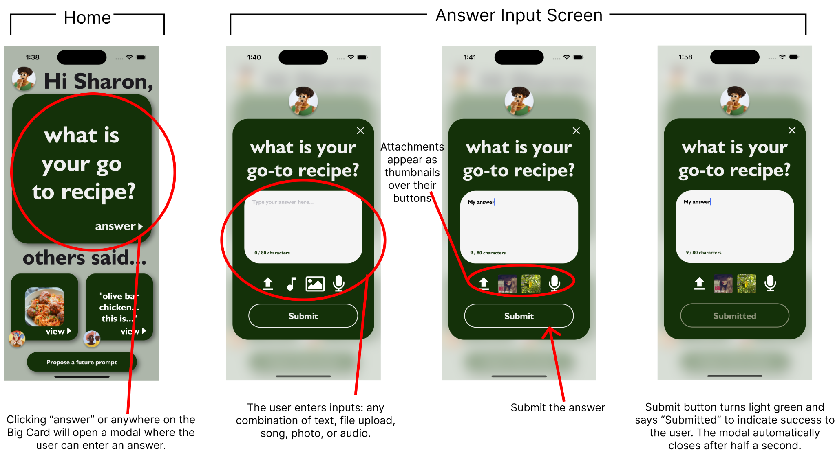
Figure 4. First task flow on hi-fi prototype capturing the steps on how to answer a prompt.

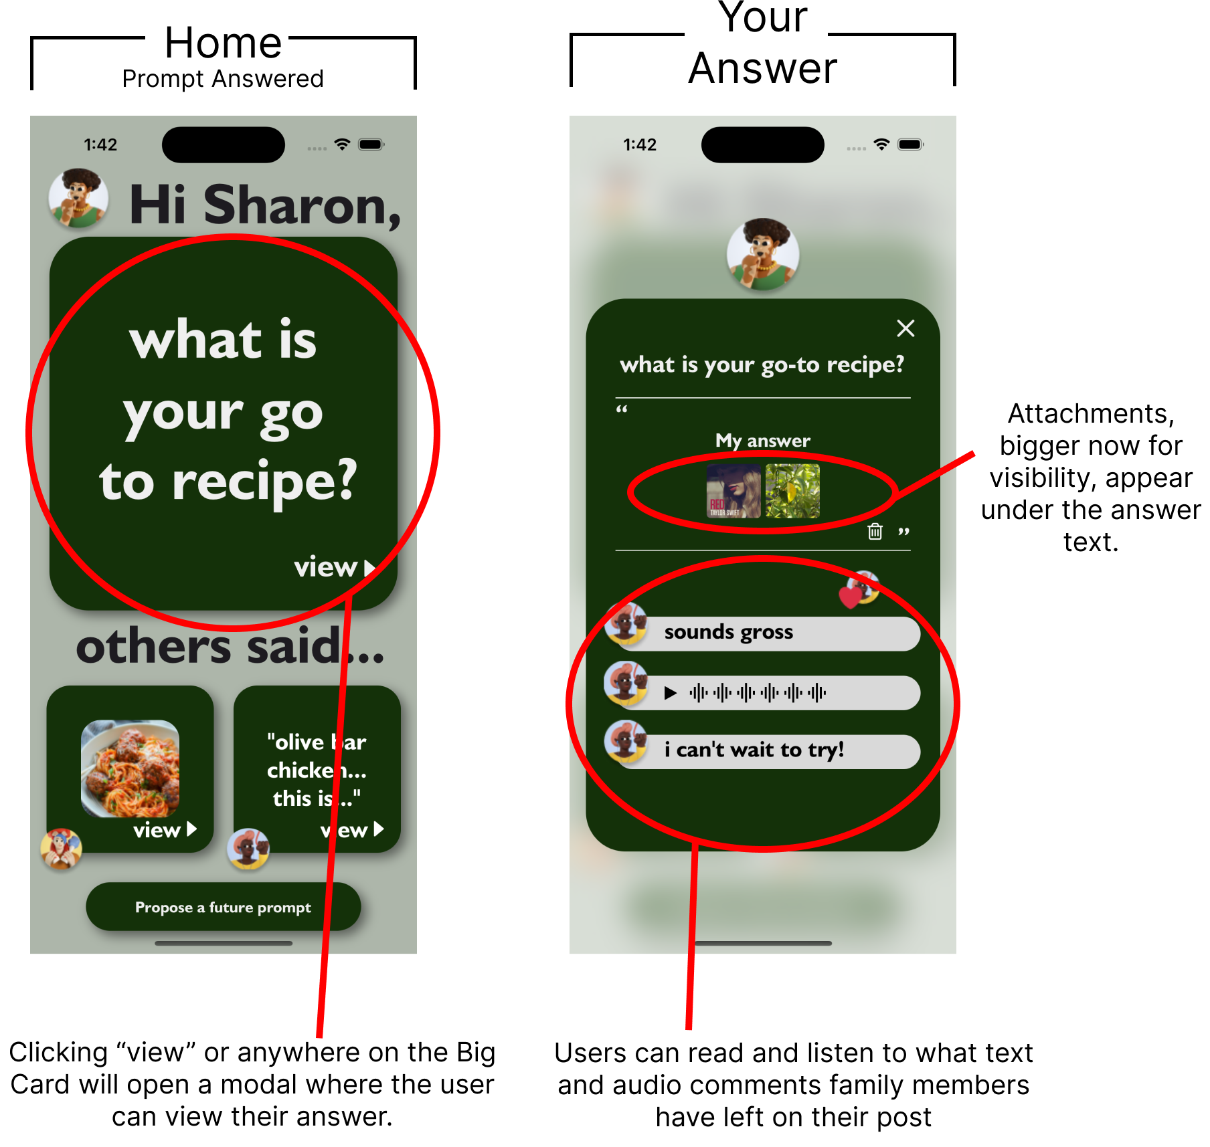
Figure 5. Changes to home screen and your answer screen after answering the daily prompt.

Moderate Task: Engaging with a Family Member’s Response to a Prompt
This task is important as it fosters intergenerational dialogue. By engaging with a family member's response, users can understand different perspectives and build upon shared stories, which is central to the app's mission of creating a collaborative storytelling environment.
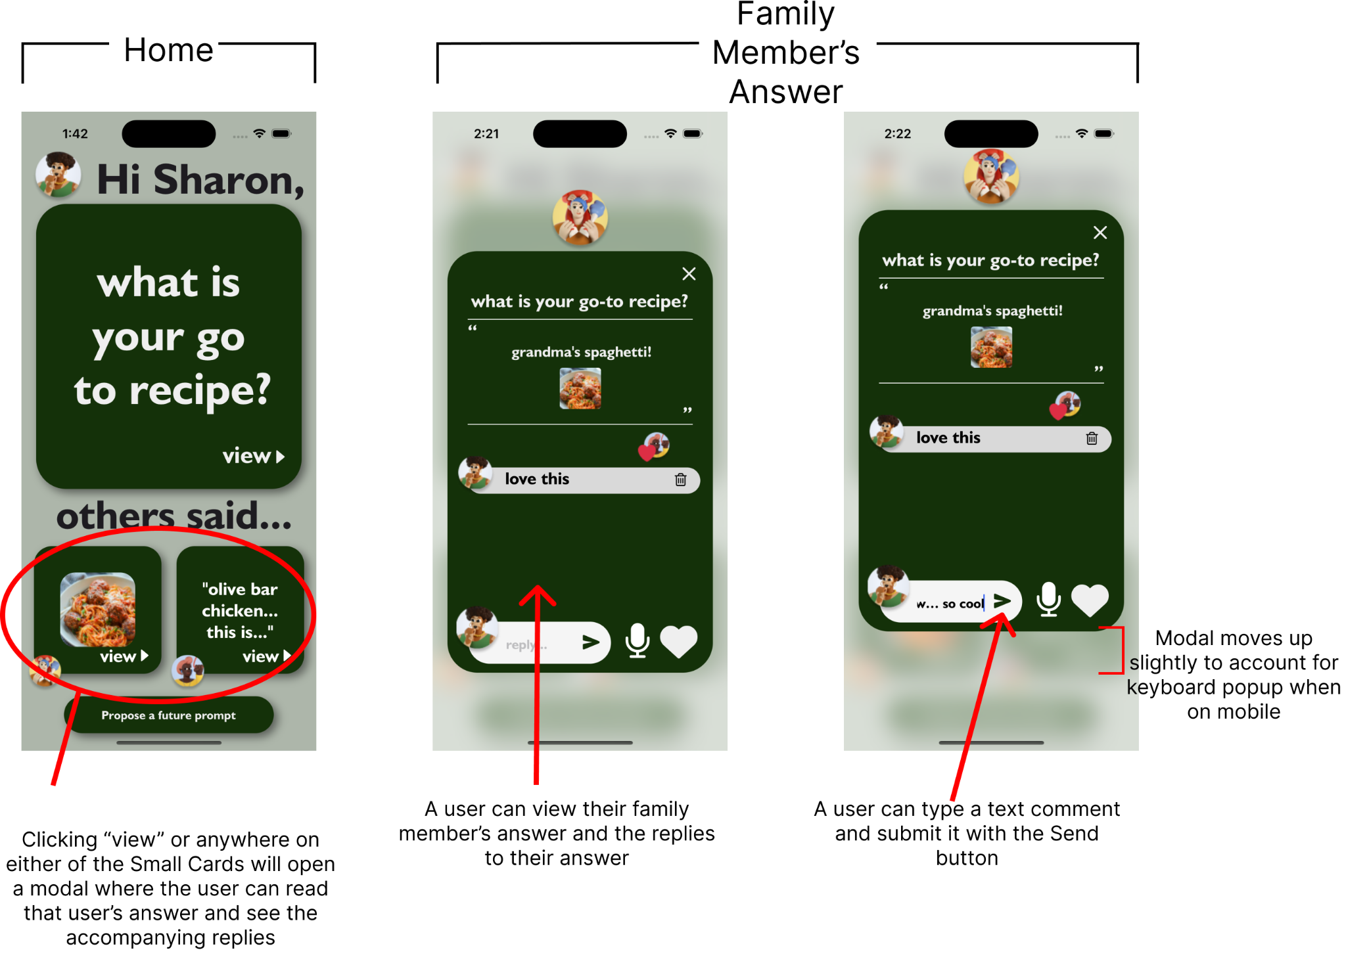
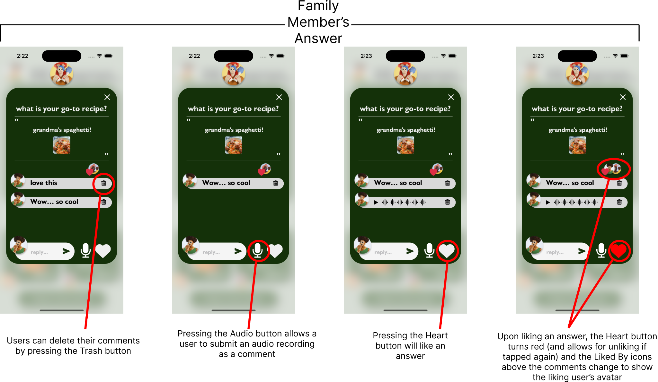
Figure 6. Second task flow on hi-fi prototype capturing how to engage with a family member’s response to a prompt.

Complex Task: Submitting a Prompt
Allowing users to submit their own prompts invites a level of personalization and autonomy over the storytelling process. It empowers users to steer the direction of family narratives.
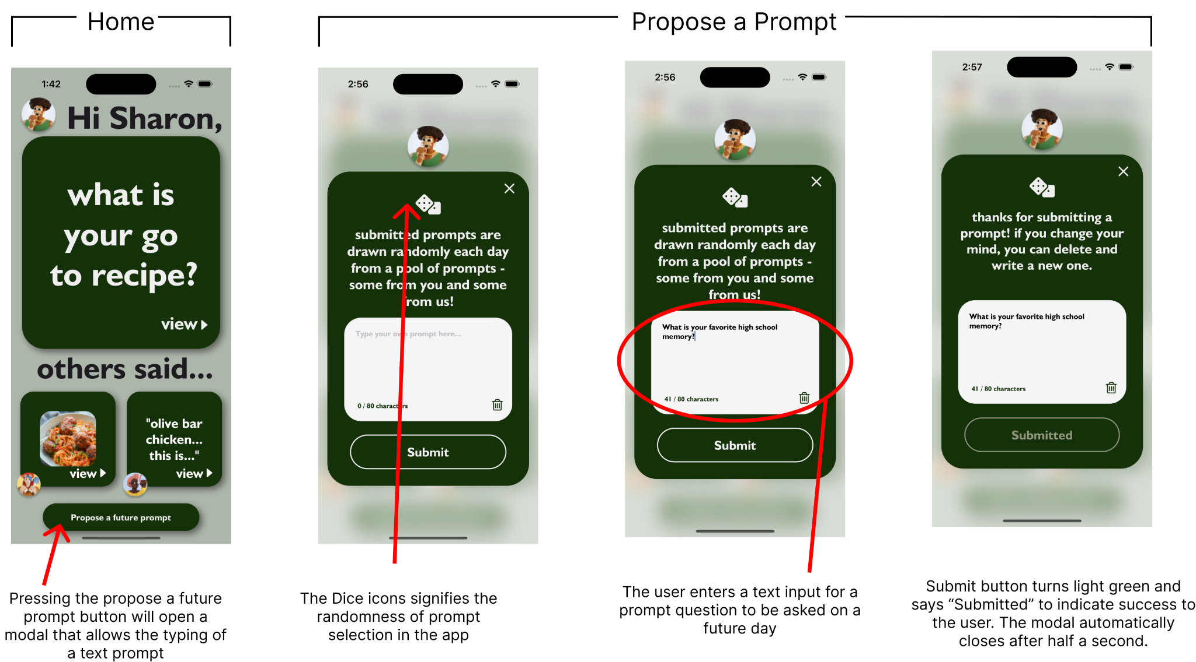

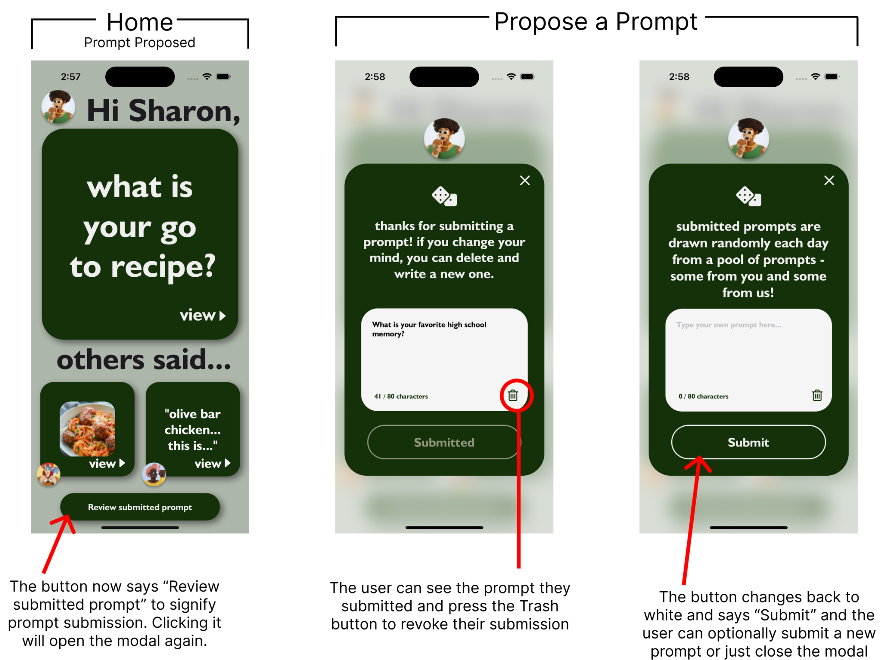
Figure 7. Third task flow on hi-fi prototype capturing how to submit your own prompt.

Exploring Various Realizations
We began our design process by exploring how our concept could be realized across different mediums. In particular, we brainstormed concept sketches for Virtual Reality (VR), Wearable (Apple Watch), Augmented Reality (AR), Mobile Application, and Near Field Communication (NFC) Tags realizations. We have included the concept sketches below.
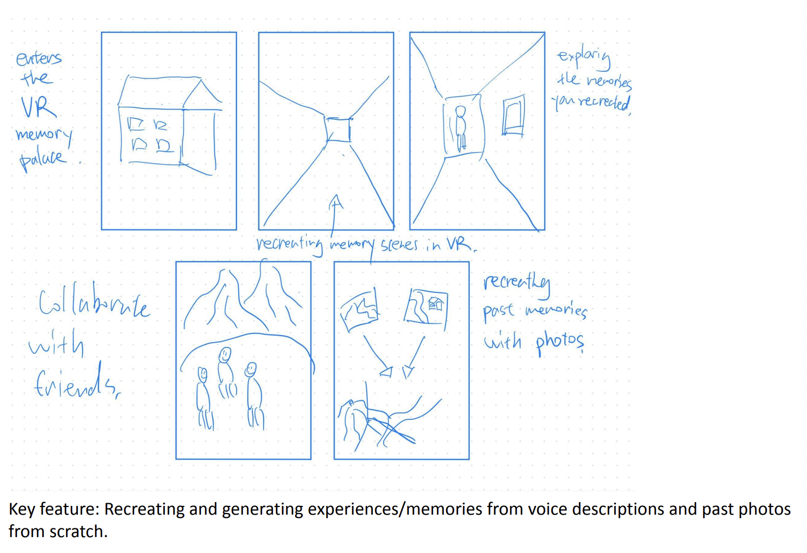
Figure 8. This is a concept sketch for the VR realization.

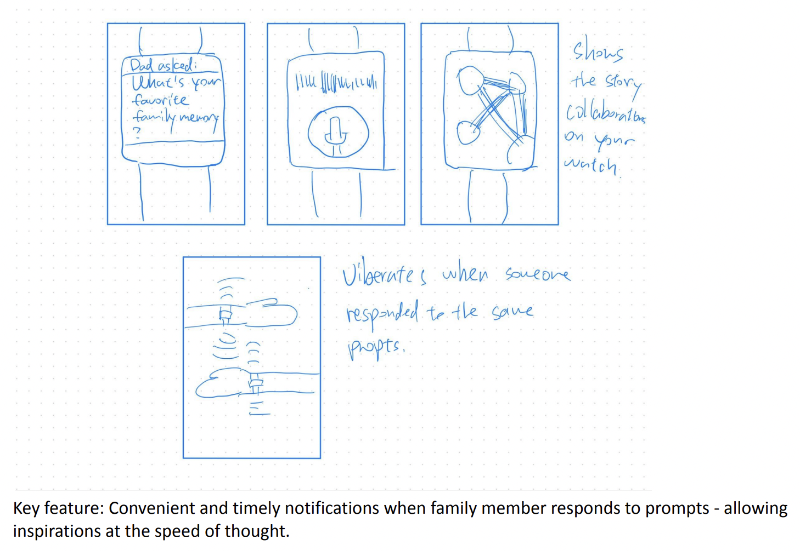
Figure 9. This is a concept sketch for the Wearable realization.

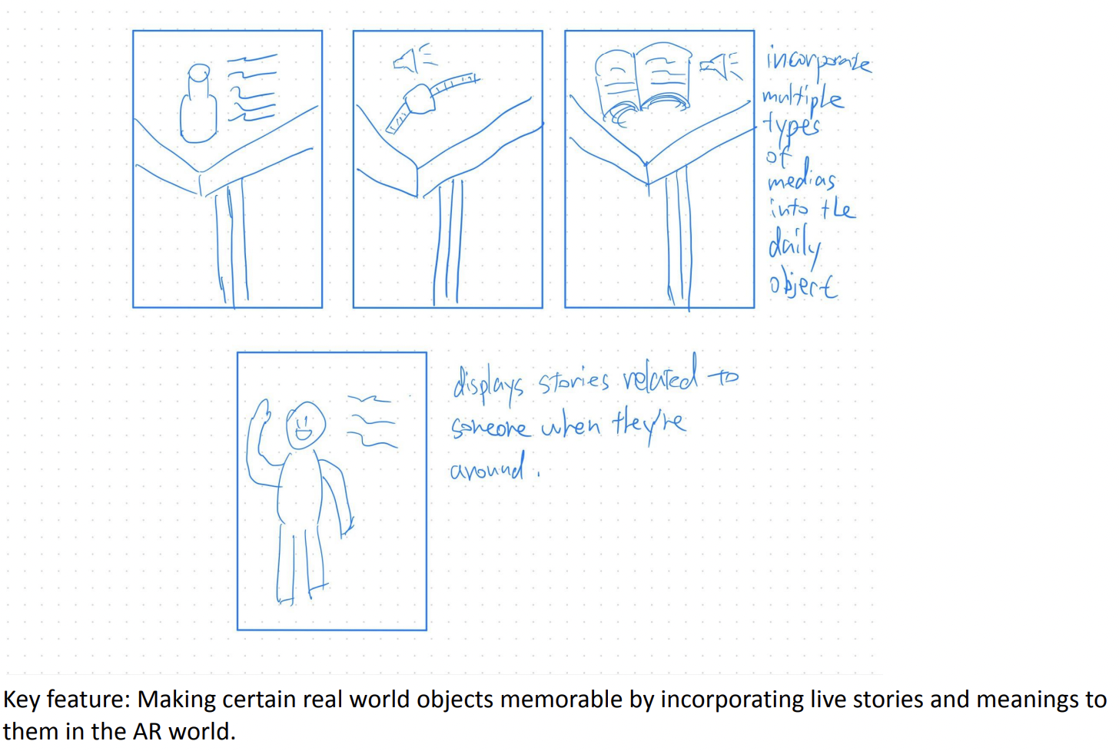
Figure 10. This is a concept sketch for the AR realization.

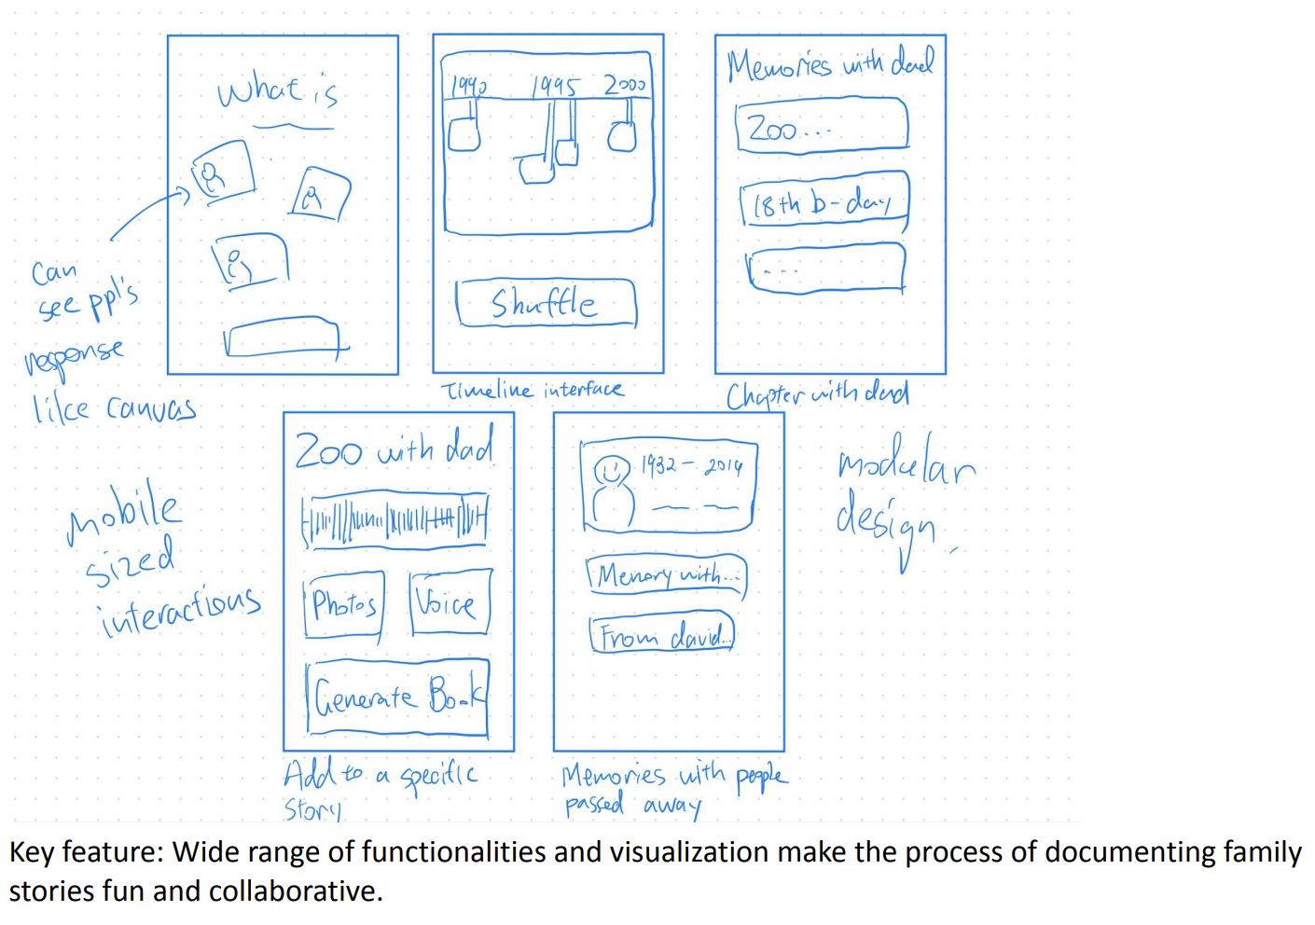
Figure 11. This is a concept sketch for the Mobile Application realization.

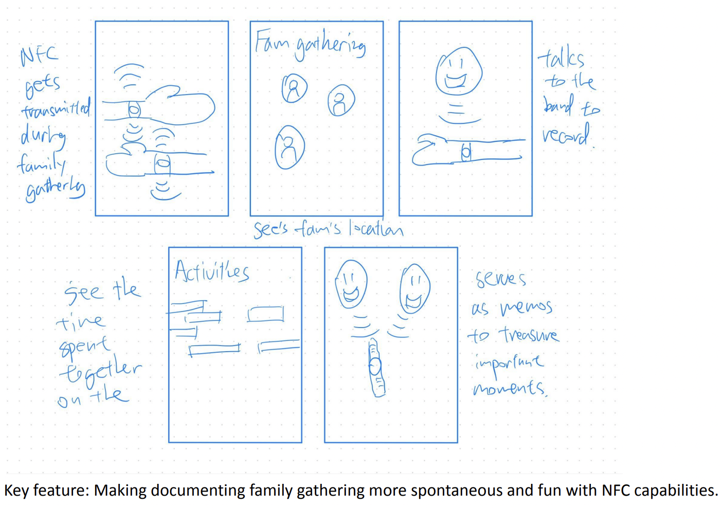
Figure 12. This is a concept sketch for the NFC Tags realization.

Developing our Top 2 Realizations
After considering the pros and cons of each realization and noting that our audience consisted of elderly people, we decided to move forward with the two realizations we felt would be most accessible and utilized by our target audience. Concretely, we further fleshed out our Wearable (Figure 5) and Mobile Application (Figure 7) realizations; the storyboards are included below.

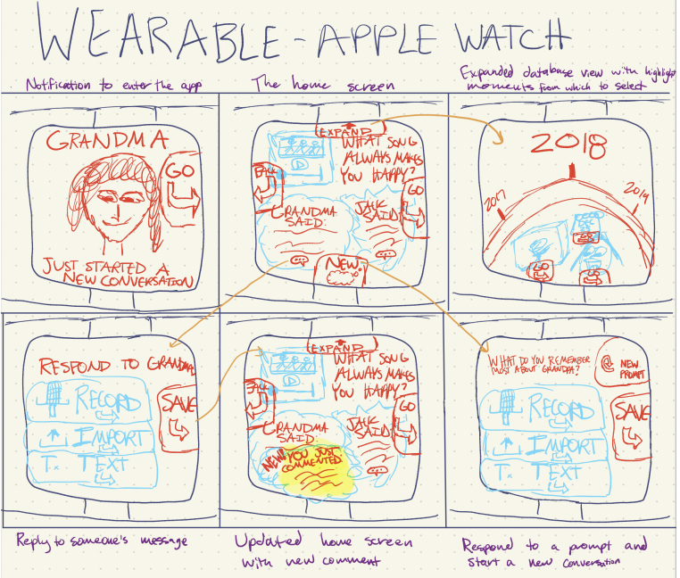
Figure 13. Storyboard of a Wearable (Apple Watch) realization
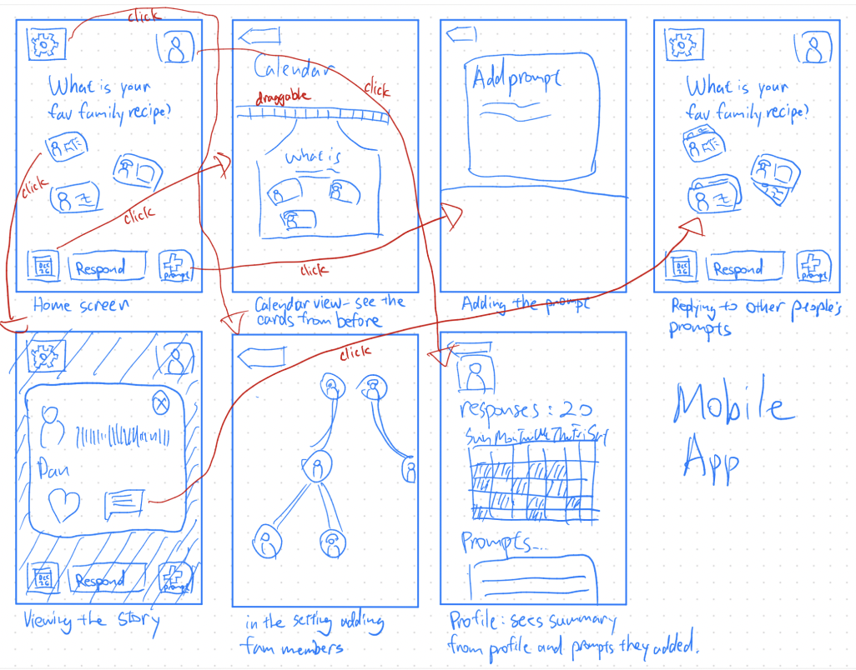
Figure 14. Storyboard of a Mobile Application realization.

Selected Interface – Mobile Application (Figure 10)
In deciding between wearable and mobile application modalities, we ultimately chose to move forward with the mobile application realization for Kin based on our core values and insights from user feedback. The mobile app format aligns with our commitment to inclusivity, offering a more significant visual and interactive space that accommodates users with diverse abilities, including the elderly and those with disabilities. It capitalizes on the familiarity and wide adoption of mobile devices across all age groups, ensuring Kin's accessibility to a broad user base. The mobile app interface also supports our dedication to creating an engaging experience, harnessing the larger screen size and versatile interaction methods like touch, voice input, and robust notification systems to foster seamless user engagement.

Low-fidelity Prototype
After selecting our interface, we created our low-fidelity prototype. The prototype was initially created on an iPad; it was then transferred screen by screen to Figma as well as hand-drawn, so we had both a digital and physical low-fidelity prototype. Interactions between screens were incorporated, linking the sketches so that specific buttons, when tapped, would guide users to the corresponding screens. We chose to make our prototype as basic as possible, and the entire prototype was hard-coded with functionality limited to clicking and selecting buttons. We also had placeholder screens to represent aspects of the app we had not yet coded or fully considered. Below are the key screens in our low-fidelity prototype, split by task and functionality.

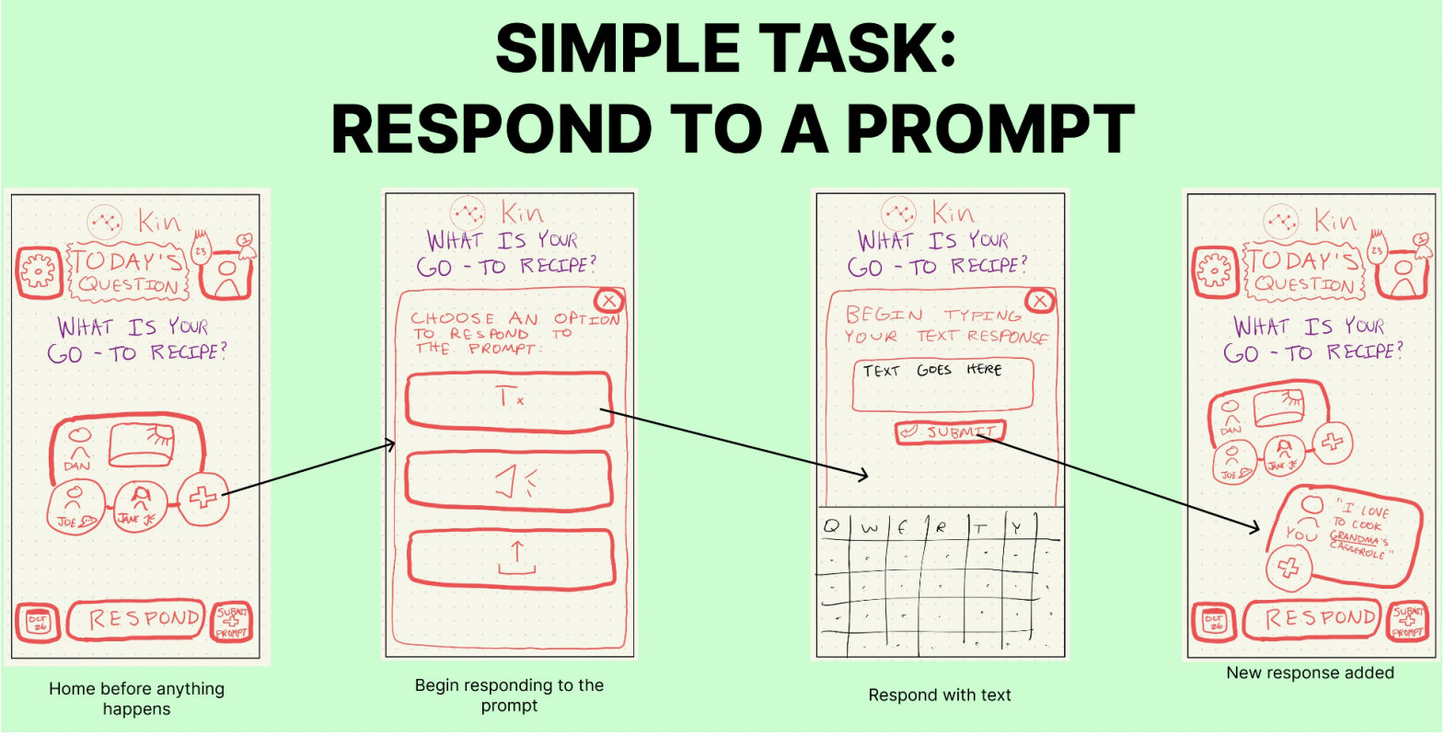

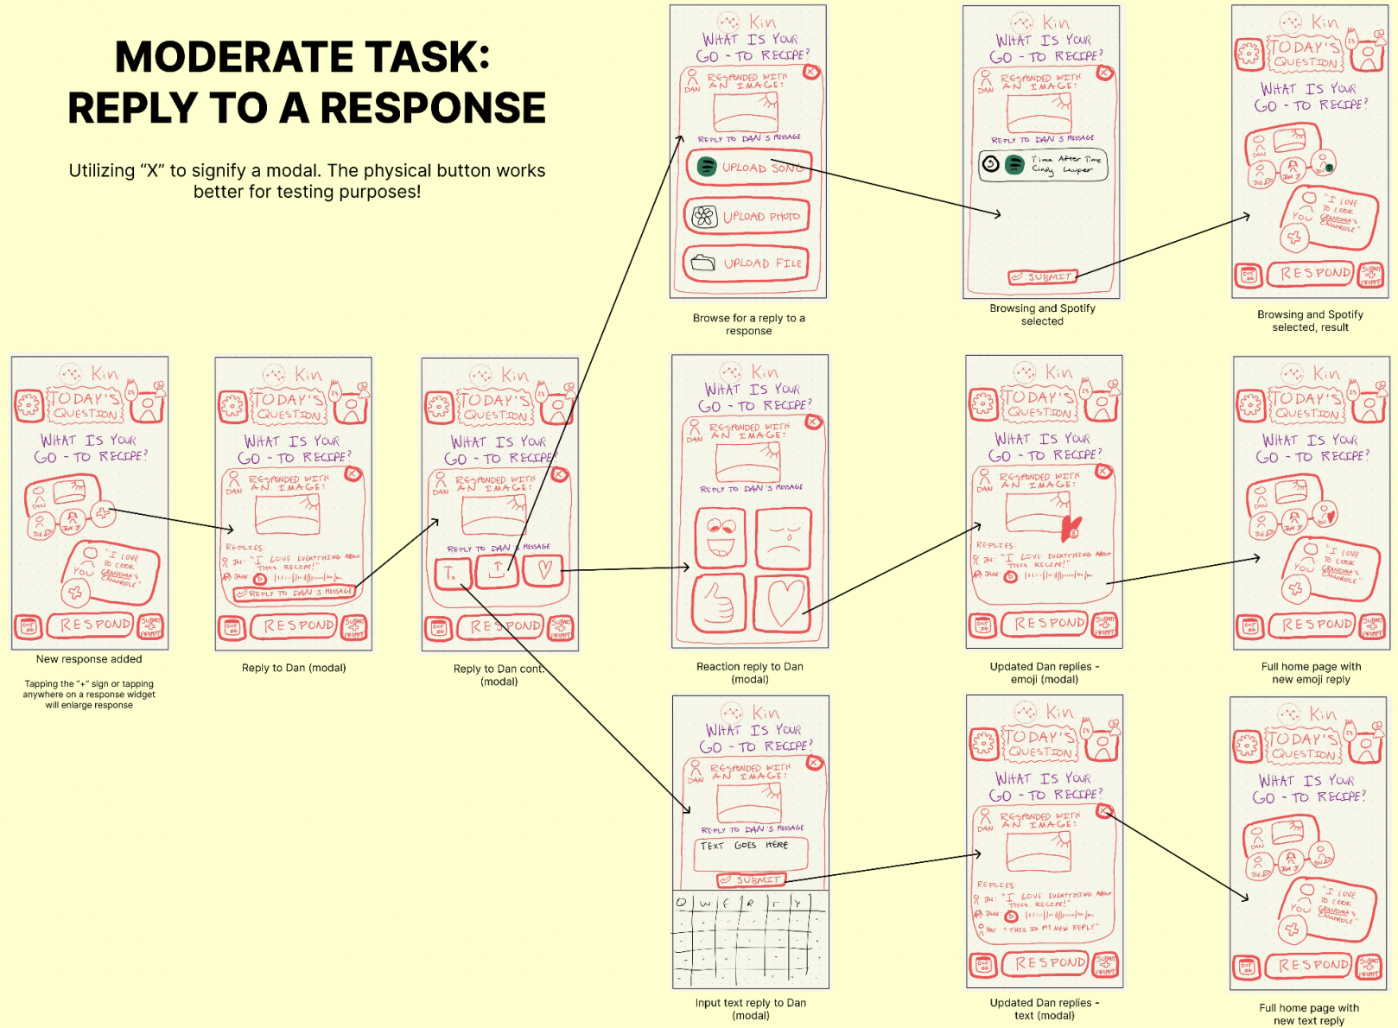
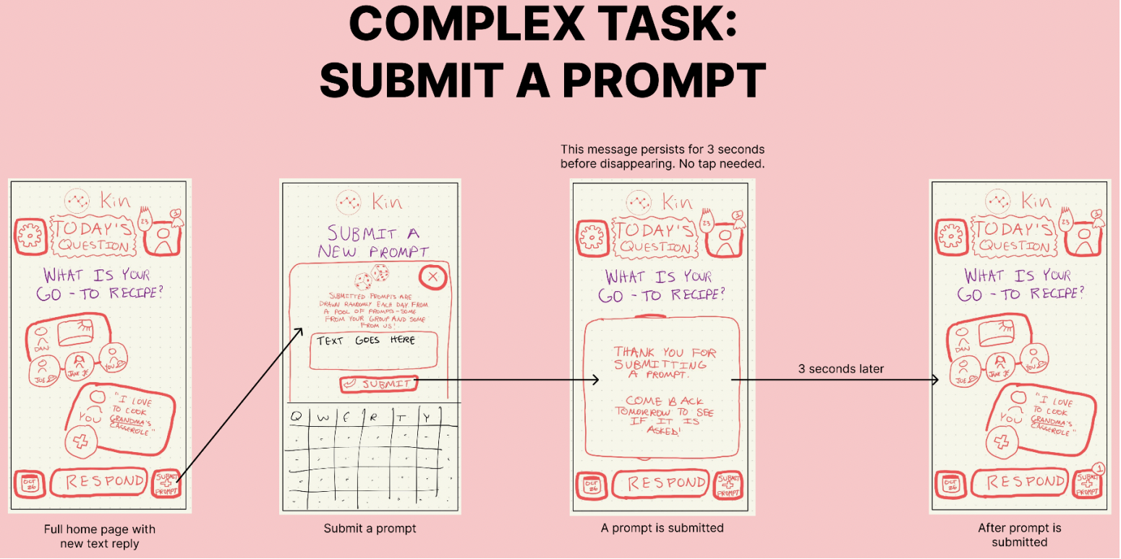

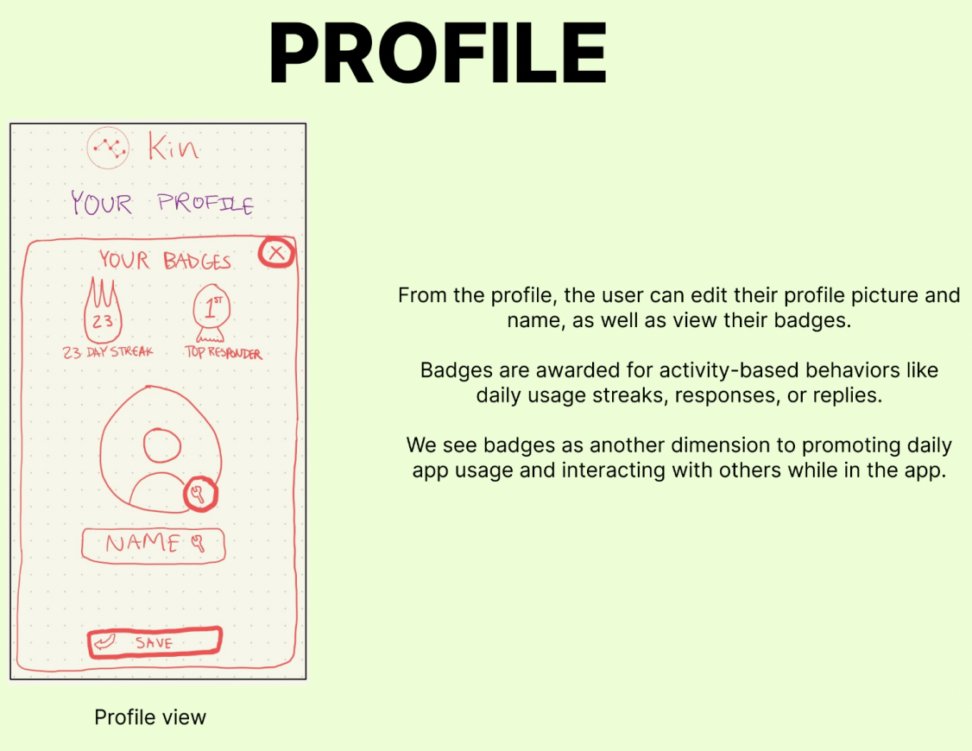
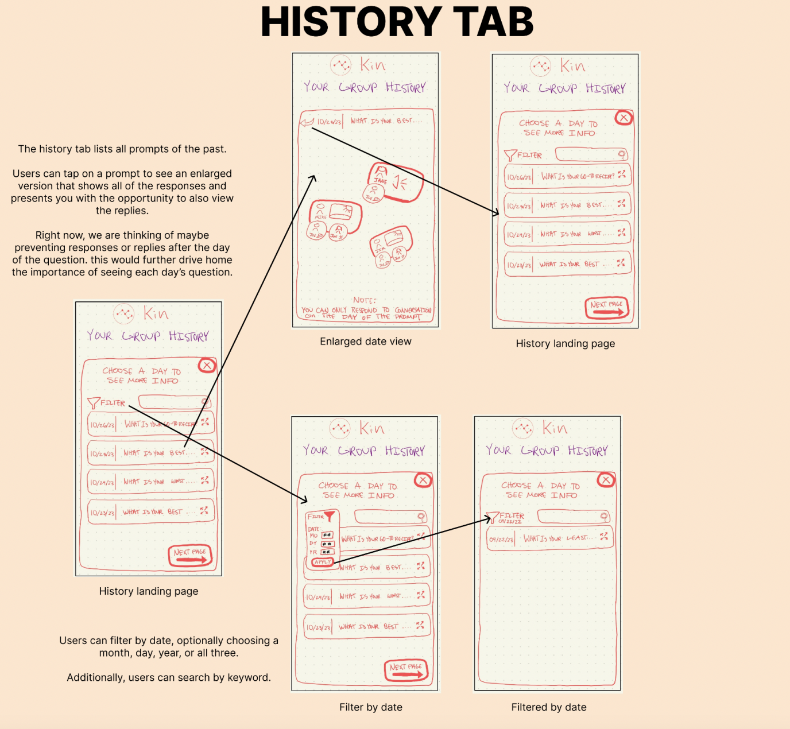
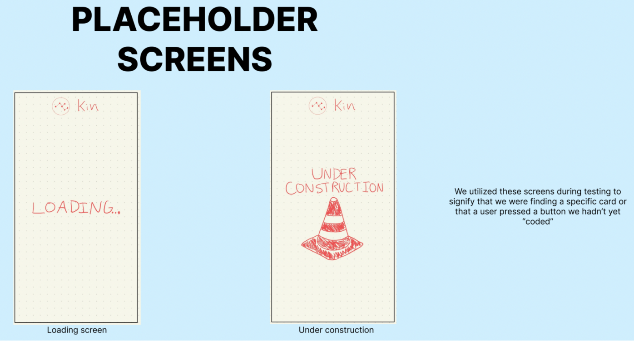
Figure 15. Key screens taken from our low-fidelity prototype.

Low-fidelity Prototype: Usability Testing
Methodology
Our methodology for conducting user tests with our low-fidelity Kin prototype was structured and user-centric, tailored to gather actionable insights from a diverse participant group. We initiated the process by introducing the project and providing an overview to ensure participants understood the context and purpose of the testing. After obtaining consent and capturing the initial reactions through pictures, we engaged users with a paper prototype—manually swapping "screens" to simulate the app experience.

We began with a simple task: onboarding users onto the app to familiarize them with Kin's interface. This task set the stage for participants to comfortably interact with the app's core functionality. Next, we asked users to respond to a daily prompt to get a tangible sense of participation. This interaction was critical to evaluating the intuitiveness of engaging with the app.

For a task of moderate complexity, we observed users as they read and replied to responses from other family members, assessing how well the platform supported meaningful engagement with shared content. This step was essential to understanding user dynamics and the app’s ability to facilitate conversations that could resonate across different ages and backgrounds.

The most complex task involved users adding their own personal prompts to the system. This tested Kin's capacity to allow users to customize their storytelling experience, a feature vital for fostering personal and familial engagement.

Throughout the process, we encouraged users to vocalize their thoughts, providing us with real-time feedback on their experience. We measured efficiency and enjoyment using a System Usability Scale (SUS) questionnaire, noting the Task Error Rate to gauge the app’s ease of use. These metrics, alongside participant feedback, were instrumental in iterating on Kin's design to enhance usability and ensure our app aligns with our values of inclusivity, engagement, intuition, and community building.

Results and Analysis
For the simple task of responding to daily prompts, 75% of participants found the interaction intuitive, while a full 100% could easily select their preferred medium of response without confusion. This suggests a strong foundation for user engagement with the core functionality of Kin, but also indicates room to improve clarity for the remaining 25%. The moderate task revealed a 75% confusion rate when it came to replying to other people’s posts, with the distinction between 'respond' and 'reply' being unclear. This informed us that while the fundamental concept is sound, the user interface requires refinement to ensure the actions are intuitive and well-understood. For the complex task of submitting a prompt, all participants encountered significant difficulty, indicating that the submission process needed to be more straightforward and prominent.

The usability goals were revisited in light of these findings. An average of three "mis-clicks" and confusion about feature placement highlighted areas where the app's efficiency could be improved. The System Usability Scale (SUS) scores provided additional insight, with the system's perceived complexity scoring 4.75 out of 10, suggesting a need for simplification.

Other observations indicated potential shifts in user demographics, with one participant expressing a preference to use the system with friends rather than family. This could suggest expanding the app's target user base to include broader social connections or rethinking the app’s target audience altogether.

Major UI Changes from Low-fi to Med-fi Prototype
Based on the feedback we received, we decided to make the following UI changes.

Home Page Streamlining
Before, the home page featured a cluttered arrangement of buttons and response cards. During usability testing, we learned that users had difficulty navigating and selecting buttons due to the crowded interface elements. Consequently, we redesigned the home page for clarity, with an enlarged prompt for easy reading and unnecessary buttons removed to reduce noise.
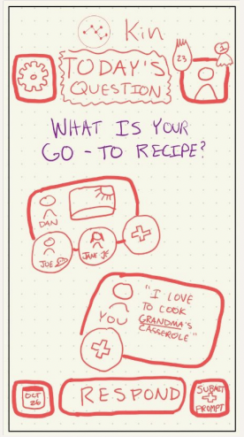  Before | 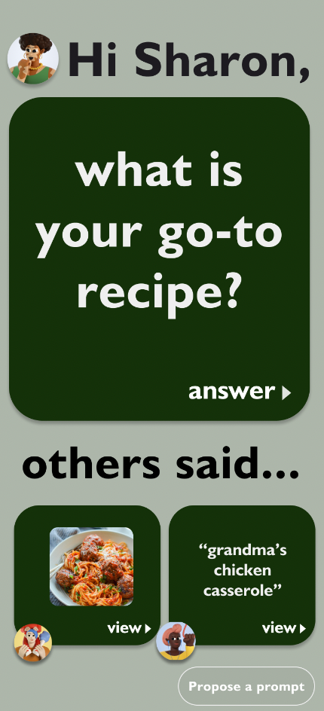  After
Figure 16. Before, buttons and response cards are congested; after, the prompt is enlarged and unnecessary buttons are removed.

Prompt Input Page Optimization
Before, the prompt input interface was crowded, with buttons occupying excessive space and causing confusion for users on how to respond. To make the response submission more intuitive for users, we refined the input UI to allow users to view their inputs immediately, creating a more streamlined and clear interaction.

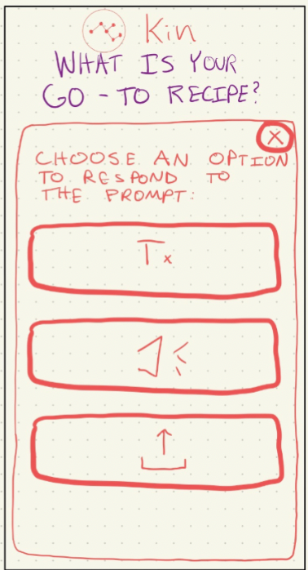  Before | 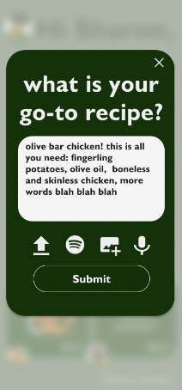  After
Figure 17. Before, buttons for the input UI take unnecessary space; after, the users can view their inputs more immediately, offering a more direct view of the UI.

Response Page Redesign
Before, oversized buttons obscured existing responses, making it hard for users to view the conversation flow. Mirroring messaging app formats that we felt would be familiar to users, we redesigned the response UI to display formats, original answers, and existing responses simultaneously.

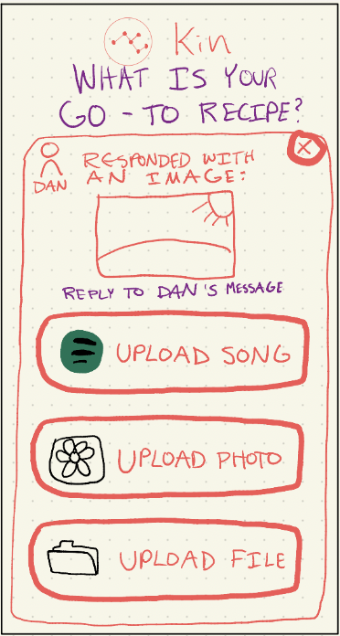  Before | 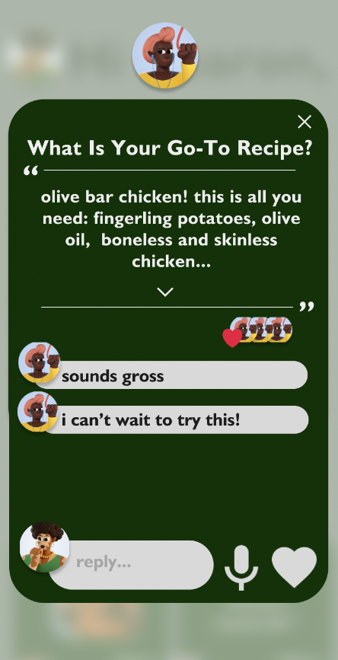  After
Figure 18. Before, the users can’t see the existing responses and see their current responses because the buttons are oversized; after, the user can see the prompt, the user’s original answer, the existing responses at the same time.

Terminology Clarification
Before, we were using the term “Response” to indicate to the user that they should press this button to respond to the prompt. User testing revealed that this was confusing terminology to use, so the term "Respond" was changed to "Answer" to better indicate the action expected from the user. This language adjustment aligns with standard conversational terms.
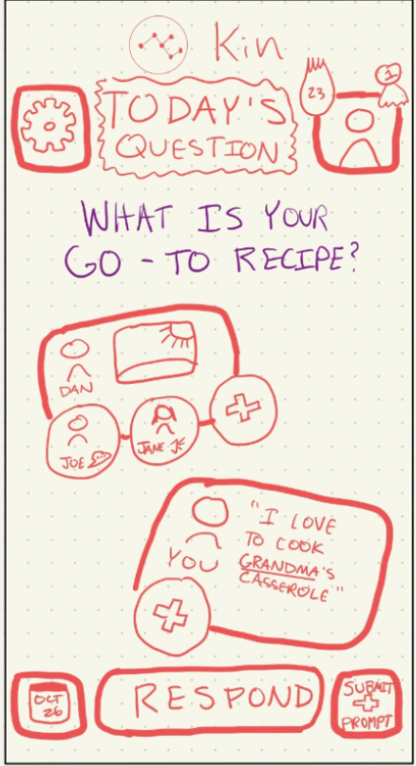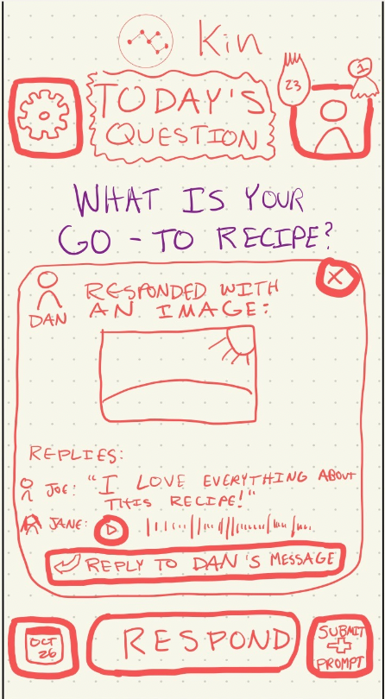  Before | 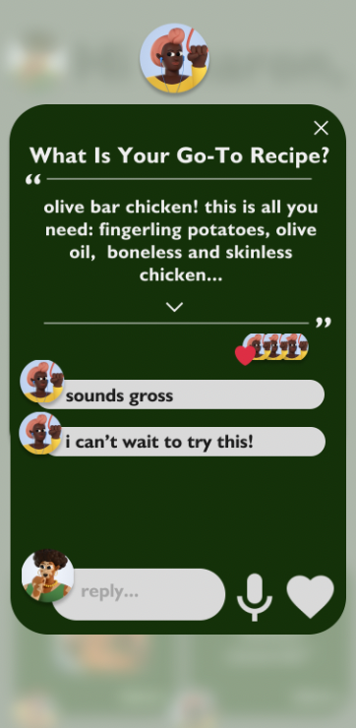  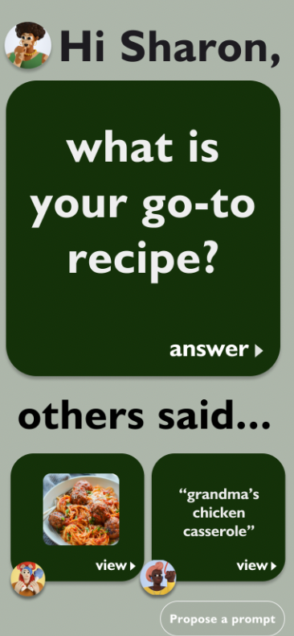  After
Figure 19. 75% of people we interviewed were confused with the terminology of Respond versus Reply, so we changed “Respond” to “Answer.”

Standardized UI Elements
We standardized UI elements across different screens for consistency because consistent UI elements reduce the learning curve for new users and create a more cohesive user experience.
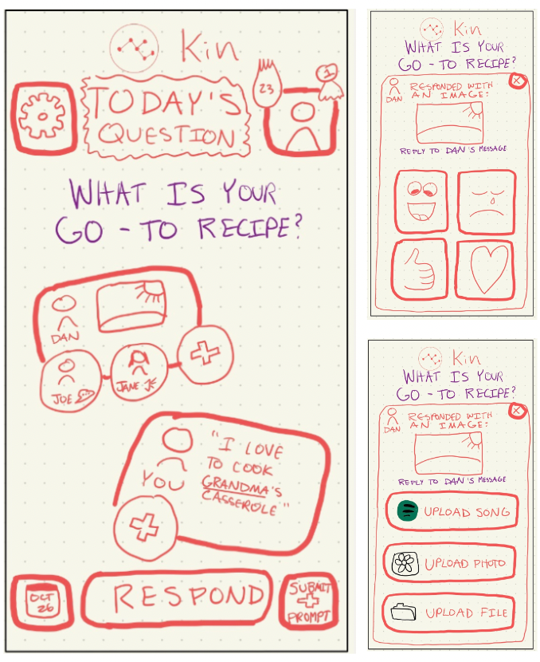  Before | 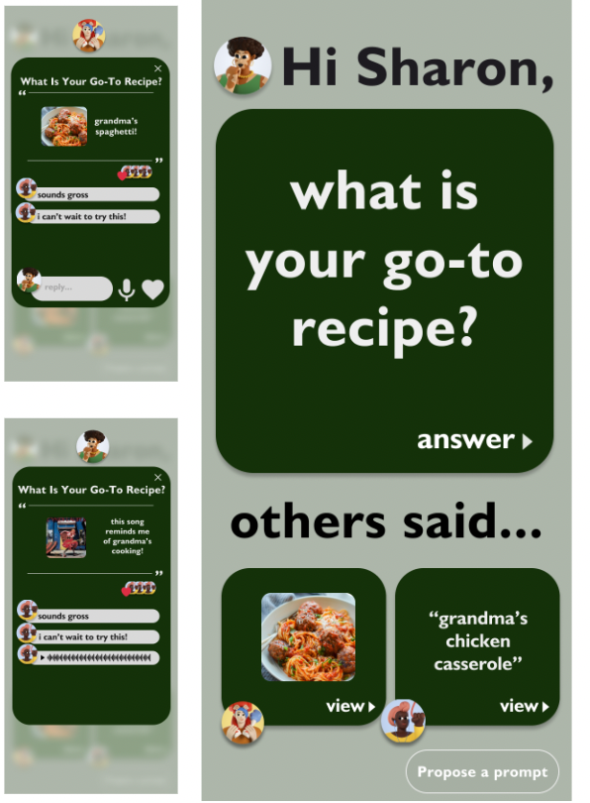  After
Figure 20. We made the UI more gridlike and standardized, with hopes of making it more accessible to users of all ages.

Med-Fi Prototype Overview. Here is our Med-fi prototype in its entirety:
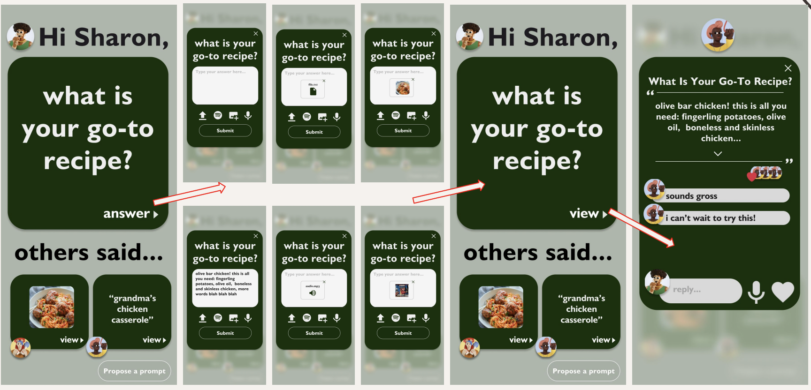
Figure 21. First task of answering prompts on med-fi prototype.
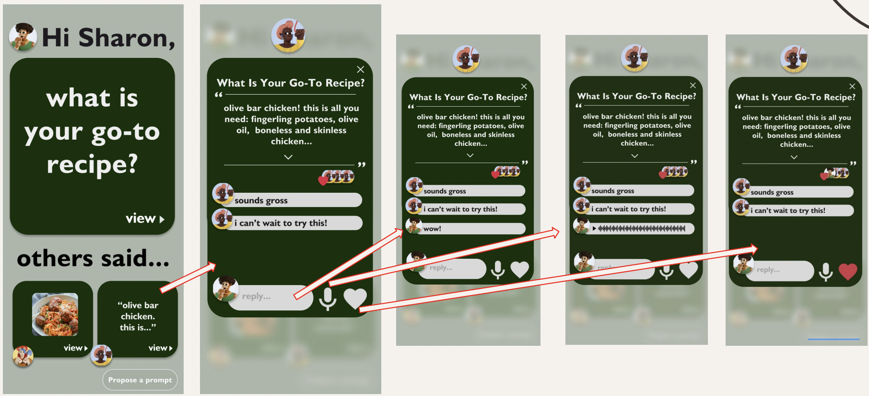
Figure 22. Second task of replying to a family member’s response on med-fi prototype.

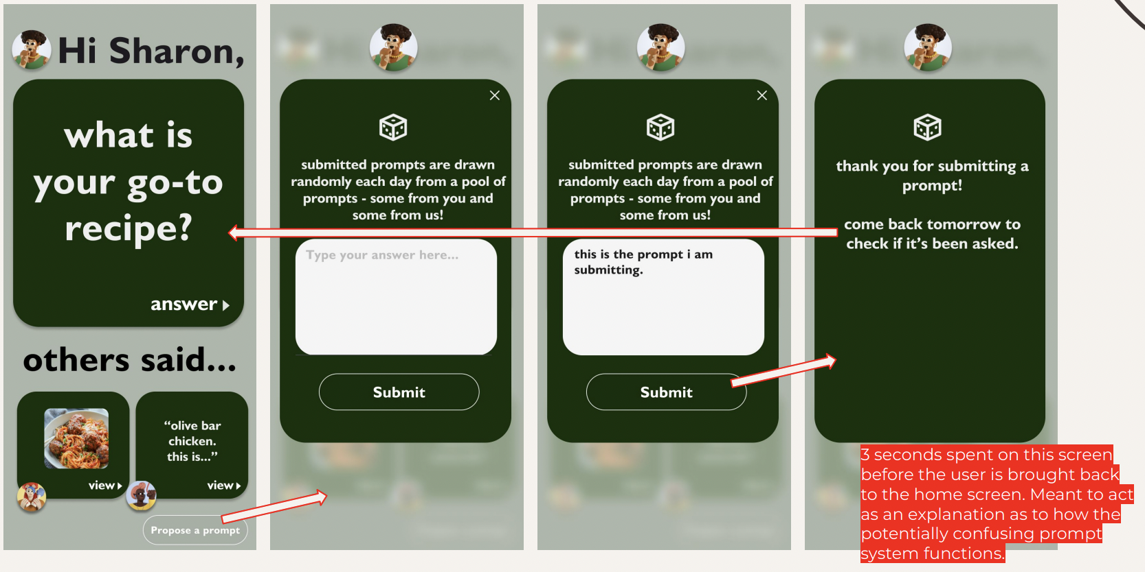
Figure 23. Third task of submitting your own prompt on med-fi prototype.

Major UI Changes from Med-fi to High-fi Prototype
We had our medium-fidelity prototype evaluated by 4 heuristic evaluators who collectively found 57 total violations, of which 46 were violations of severity 1 and 2 and 11 were violations of severity of 3 and 4. When designing our high-fidelity prototype, we prioritized all 11 severity 3/4 violations. Major violations of focus included user control & clarity issues, accessibility & interface consistency concerns, and major error prevention issues.

Below, we discuss each severity 3 and 4 heuristic violation, along with our response to the violation. Our severity 1 and 2 violations were mostly cosmetic and therefore didn’t require much changes; it was focused mainly on standardizing UI.

Task 1: Responding to a prompt
H2 Match between system and world - Severity: 3
- Issue: Our med-fi prototype used a Spotify logo to signify the button users would press in order to upload music to their responses. Our evaluators found that the use of a Spotify logo could confuse or exclude non-Spotify users.
- Action Taken: Changed to a generic music icon to ensure inclusivity, especially along age-related lines as elderly users may not be able to identify the Spotify logo, and reduce errors from non-Spotify users who may not be familiar with the Spotify logo.

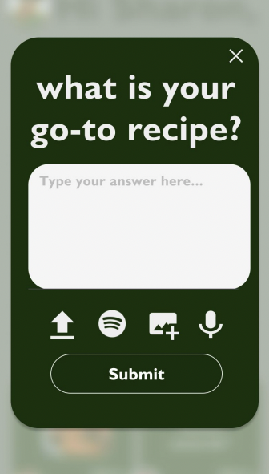  Before | 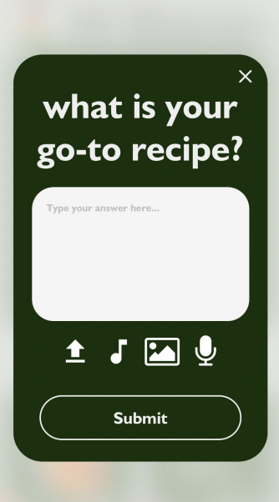  After
Figure 24. The Spotify logo is too brand-specific, so we changed the icon from the Spotify logo to music logo which is more recognizable.

H5 Error prevention - Severity: 4
- Issue: In our med-fi prototype, when responding to a prompt, all response options (file, song, image/video, voice memo) were grouped under a section labeled “type your answer here.” Our evaluators said this could lead to user confusion, as it implies that a text response is required, even for non-text media uploads like voice memos.
- Action Taken: The app was updated to allow users to respond to prompts using various media types without the necessity of adding text. Users can choose to respond with any supported media type and can combine different media types as they wish, enhancing usability and providing greater flexibility in how they can engage with the prompt.

H3 User control and freedom – Severity: 3
- Issue: In our med-fi prototype, users were unable to undo their text responses or switch to a different response format once their text is typed. The only way for a user to switch their response out of a text response was by starting over by pressing the “x” button – this restricted the users’ ability to respond to prompts in the format of their choosing.
- Action Taken: Add an ‘X’-like button and edit options to allow people to back out of their response format and prior response.

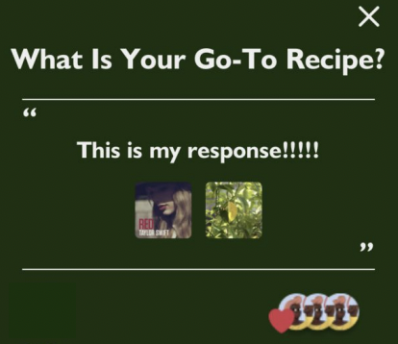  Before | 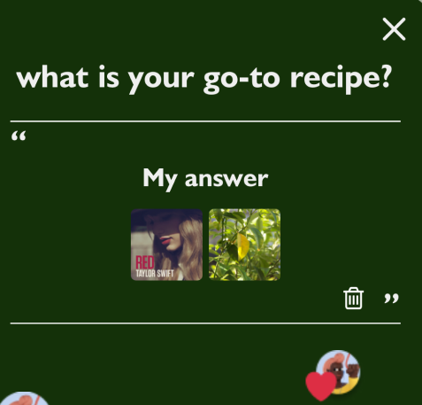  After
Figure 25. Users are now able to modify their uploads, which supports their ability to edit responses and create new ones.

H10 Help and documentation – Severity: 3
- Issue: In our med-fi prototype, the interface wasn’t able to support multiple uploads from the same media type.
- Action Taken: We decided to ignore this heuristic violation because we felt that allowing too many uploads would clutter the otherwise simple interface. Four total attachments (file, song, photo, audio) as a maximum is plenty.

Task 2: Responding to family member’s response
H4 Consistency and standards – Severity: 3
- Issue: In our med-fi prototype, users were unable to provide multiple comment responses or like and comment at the same time – behavior that is consistent with platforms like Instagram and Facebook.
- Action Taken: Enable users to leave multiple comments AND like the post simultaneously.

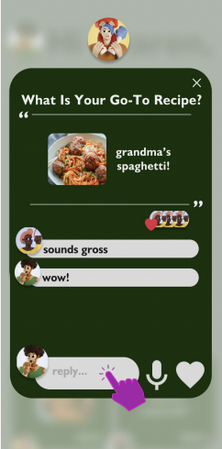  Before | 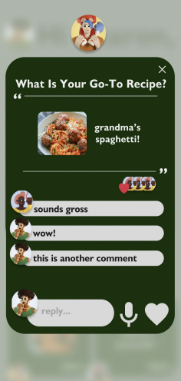  After
Figure 26. Users are now able to express thoughts in more than one comment submission and through likes.

H3 User control and freedom – Severity: 3
- Issue: In our med-fi prototype, users were unable to delete, edit, or change their comments.
- Action Taken: Add a delete button that allows users to delete their comments in case they change their mind.
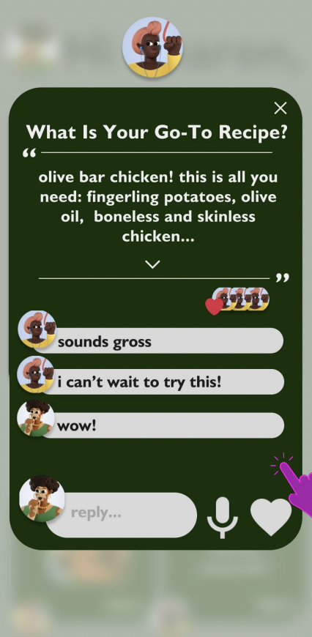  Before | 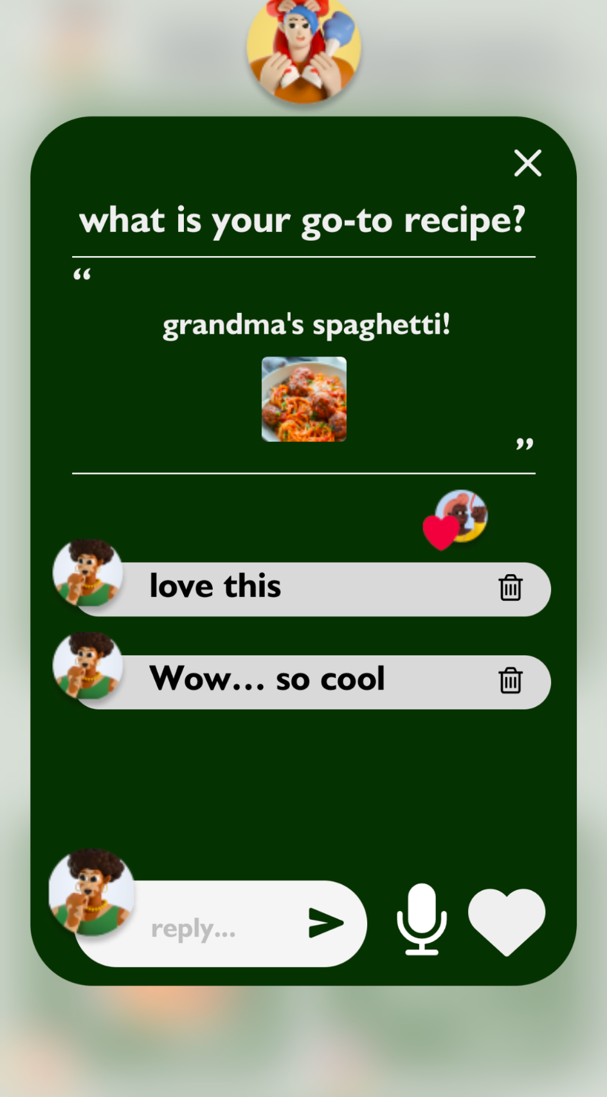  After

Figure 27. Users are now able to delete their comments even after those comments have been submitted.

Task 3: Submitting your own prompt
H11 Accessible Design – Severity: 3
- Issue: In our med-fi prototype, once the user submitted a prompt, the system displayed a success message on the screen that disappeared after a fixed number of seconds. Having text that flashes and disappears all within the span of a few seconds may create issues for visually impaired readers or the elderly who need more time to read and understand text prompts.
- Action Taken: Add an “X” button instead of having disappearing text.

H5 Error Prevention – Severity: 3
- Issue: In our med-fi prototype, once the user submits a prompt, the app automatically loads it into the system without asking the user to confirm their question or giving them the chance to edit their submission.
- Action Taken: Add a button that allows users to delete their prompt submission. Add an instruction that tells them that they have the option to delete their prompt submission and write a new one.
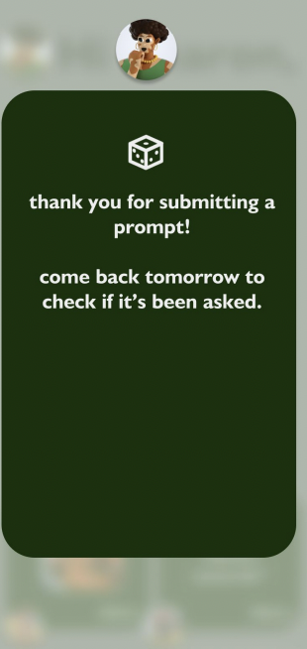  Before | 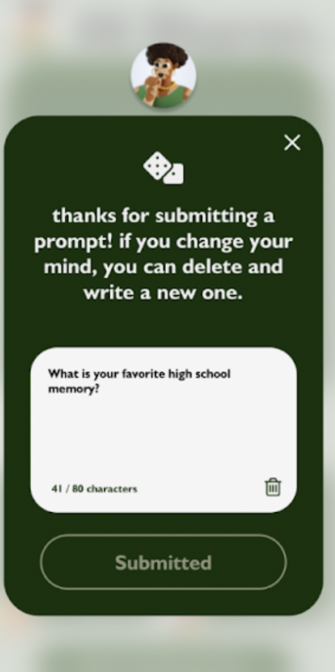  After
Figure 28. Users are now able to exit out of the confirmation message as well as delete their prompt submission, reflecting changes made to both of the violations outlined above.

H1 Visibility of system status – Severity: 3
- Issue: In our med-fi prototype, users are unable to view previously submitted responses or view the status of their submitted responses. According to our evaluators, the lack of feedback on the status of a submitted response creates uncertainty and potential frustration for users.
- Action Taken: We decided to ignore this heuristic violation because we felt that allowing users to see the prompts they have submitted ruins the lottery type feel of the submission system. Ideally, we want users to be pleasantly surprised when they open the app and see a prompt that they previously submitted.

H5 Error prevention – Severity: 3
- Issue: In our med-fi prototype, there was no in-built error mechanism that let users know whether their proposed prompt submission met Kin’s standards.
- Action Taken: For the purpose of our hi-fidelity prototype, we chose to ignore this heuristic evaluation because it was important to us for users to have the agency to put creativity into their prompts. For example, some of the proposed prompts could contain inside family jokes, and there is no good way to screen those more subjective submissions.

H2 Match between system and world – Severity: 3
- Issue: In our med-fi prototype, when users are ready to submit their own prompt, the box indicating where they should write their prompt says “Type your answer here…” This makes no sense because users are not entering a response to a question but asking a question themself.
- Action Taken: Change prompt instructions to “Type your own prompt here…”
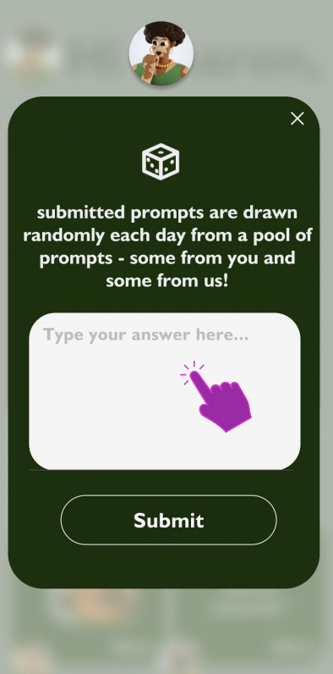  Before | 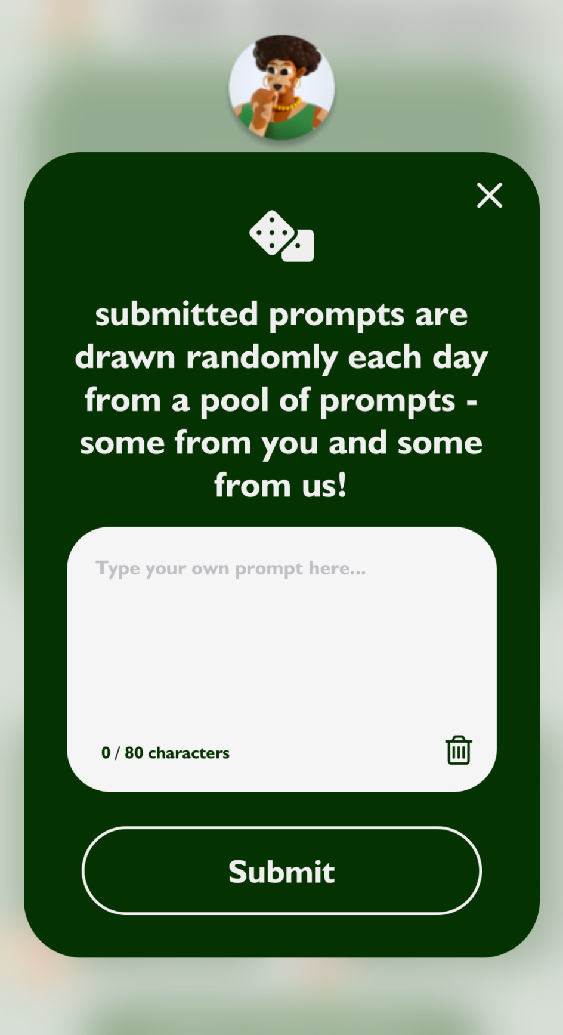  After
Figure 29. We changed the wording from “Type your answer here” to “Type your own prompt here” to be more precise and clear to the user.

Values in Design
Identified Values
Our solution is guided by three primary values:
- Intuitiveness: We are committed to creating an interface that is straightforward and user-friendly for individuals of all ages, with a keen focus on the elderly demographic to ensure that they can navigate the platform with ease.
- Playfulness: The platform is designed to be light-hearted and engaging, providing a stress-free and enjoyable user experience.
- Aesthetics: It is imperative that our platform's visual appeal resonates with a diverse user base, encompassing a broad spectrum of gender identities and age groups.

Integration of Values into Design Features
- Intuitiveness: This value is manifested through the design's simplified layout. Interface elements are optimally sized, and the navigation is streamlined, placing every feature within a couple of clicks. For example, users can quickly find and use the prompt submission feature, which is a central aspect of the app's functionality.
- Playfulness: To embed this value, we've incorporated features like the prompt submission process, which borrows the unpredictable nature of drawing cards, adding an element of surprise and engagement. Additionally, the conversational features are designed to be interactive and entertaining, mimicking natural dialogue.
- Aesthetics: We've chosen a color palette of calming earth tones and implemented rounded edges within the UI to create a universally pleasant and inviting experience. This approach aims to appeal to a wide audience while ensuring clarity and readability.

Value Tensions
A tension we navigated was between the values of Intuitiveness and Aesthetics. Striving for a visually appealing design could potentially complicate the user interface. Our solution was to carefully select fonts and color schemes that harmonize functionality with visual appeal, ensuring that elements are both legible and aesthetically pleasing.

To address these value tensions, we conducted user testing to balance aesthetics with usability. When conflicts arose, we erred on the side of functionality to maintain the integrity of the user experience. For example, we opted for a more generic music icon instead of a Spotify-specific one to avoid potentially alienating users who don’t use Spotify.

Final Prototype Implementation
Tools
We used a wide variety of tools to design our prototype of all fidelities: low, mid, and high. Here, we provide an overview of the tools we used during our design process.
- Goodnotes: Our initial design sketches were created using Goodnotes on the iPad, which afforded us the flexibility to rapidly produce and scale sketches.
- Figma: As our design matured, we transitioned to Figma for medium-fidelity prototyping. Figma's strengths lie in its ability to create industry-standard interfaces, simulate close to real-world interactions, foster collaboration, and streamline wireframing. A minor drawback is the learning curve associated with using its more advanced features.
- GitHub: We utilized GitHub as a central repository for version control, allowing for efficient tracking of iterative updates and collaborative development. A minor drawback was that GitHub requires a solid understanding of version control principles which was a barrier for some of us as we began developing our prototype.
- VSCode: VSCode served as our code editor, providing tools for writing and debugging code, particularly with the Expo extension.
- React Native: React Native was our chosen application framework due to its flexibility and intuitiveness; its library support enabled us to implement extensive functionality.
- Expo: Expo facilitated real-time visualization and testing of our app, enhancing our development workflow.

Wizard of Oz Techniques
We applied WOZ techniques to simulate functionalities before they were fully implemented, such as:
- Temporary storage of user inputs like answers and attachments, simulating backend functionality.
- A placeholder for a prompt generation algorithm, with selected questions giving the illusion of randomness.
- A mock-up prompt submission process, which was not fully functional.

Hard-coded Techniques
Certain elements were hard-coded in the prototype for demonstration purposes:
- Family member comments and answers were pre-defined.
- A default song submission, specifically a Taylor Swift song, was used to represent music upload functionality.
- The user’s name was consistently displayed as "Sharon" across the prototype.
- Family member profile pictures and 'likes' were also hard-coded, as was the inability to modify the family member list.

Reflection & Next Steps
Throughout this quarter, one of the most profound learnings has been the significance of needfinding and empathy in the design thinking process. We were constantly reminded of the value in approaching the problem space with an open mind, devoid of preconceived solutions. This approach has reinforced the principle that to innovate effectively, one must first deeply understand and connect with the users' experiences, challenges, and needs.

Our project served as a testament to the efficacy of design thinking, particularly the power of empathy in fostering innovation. Engaging closely with our users, such as Michele, a 77-year-old avid storyteller, we gleaned valuable insights into the desires of older individuals to share their narratives while maintaining autonomy over the storytelling process. Similarly, conversations with Sahir, a 20-year-old Stanford student, brought to light the pivotal role of privacy in the sharing and preservation of personal stories. These interactions underscored a fundamental principle of our approach: to prioritize the intricacies of the problem space over any preconceived solutions.

Our future steps would focus more on ensuring Kin’s readiness for real-world application, which we believe requires addressing the following:
- Privacy Measures: We would implement robust privacy safeguards to protect the sensitive nature of the stories shared on Kin. This includes secure data encryption, user-controlled privacy settings, and transparent data handling policies.
- Data Ownership and Rights: Clarification of data ownership is paramount. We would establish clear terms of service to ensure users retain ownership of their stories and understand their rights.
- Adaptability to Family Dynamics: Kin must be flexible enough to fit into the existing social structures of different families. We would focus on customizable features that allow families to tailor their interactions according to their specific traditions and communication styles.

Thank you so much for coming along on Kin’s design journey. Creating this project was an incredible experience, and we’ve come such a long way from conducting needfinding interviews to developing and iterating on our final product. Thank you so much, Professor Landay and our CA Grace Zhou, for their guidance on our project.

For additional information on our design process, check out our website: https://web.stanford.edu/class/cs147/projects/PreservingthePast/kin/.

